**Design document**

**Of City Simulator**

*Iteration 1*

1. 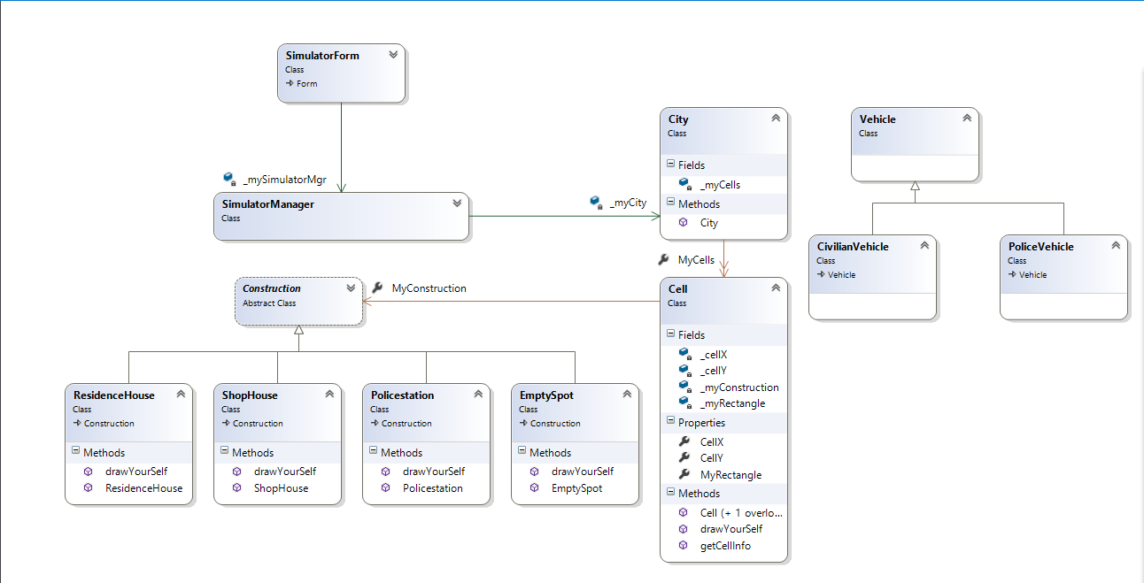**Class Diagram**
2. **Sequence diagrams**

* *Generating grid*

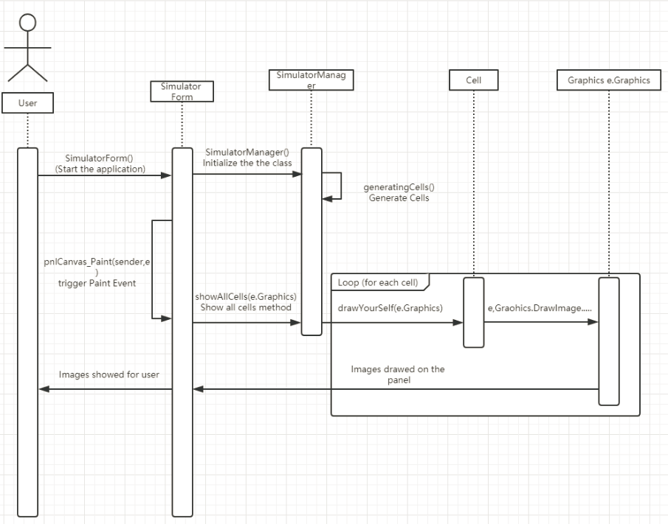

* *Detecting fields in the grid – illustration can be found on the git page of the project in “Documents” folder and the name of the file is “detectAndDrawSquare.pdf”*
* 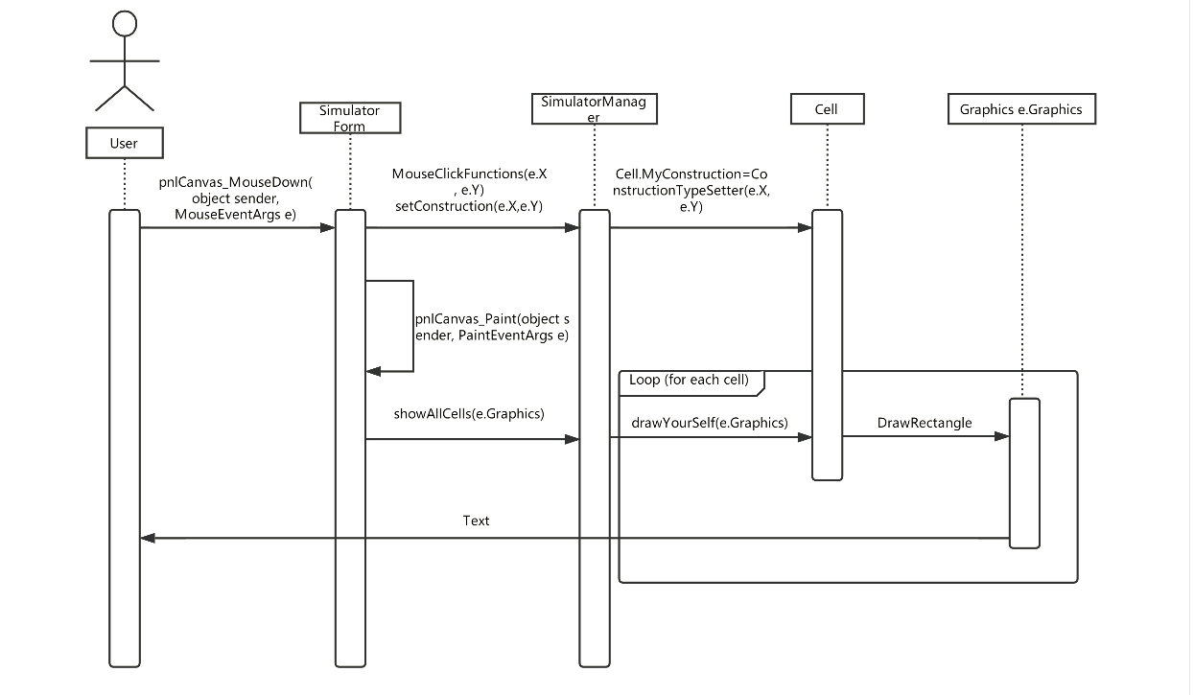Building a construction